Analysis 1:
RI2.8: Describe how reasons support specific points the author makes in a text.
- Identify the key points in a text (K)
- Identify details that support the key points (K)
- Describe how reasons support the author's specific points (K)

RI2.9: Compare and contrast the most important points presented by two texts on the same topic.
- Identify the most important points presented in two informational texts on the same topic. (K)
- Compare the most important points in two informational texts on the same topic. (R)
- Contrast the important points in two informational texts on the same topic. (R)

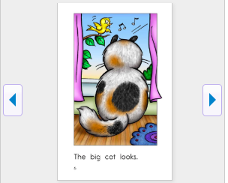
Sample A reading

WIDA Level two expectations:
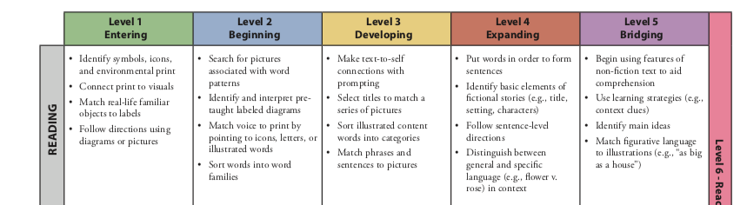

Analysis 2:
- Text needs to:
  - Be short simple sentences with repetitive sentence patterns and white space
  - Be supported by graphics with largely tier 1 vocabulary
- As this is not a writing assessment, student does not have to produce writing to demonstrate standard proficiency
- If student’s lexicon prohibits reading, text can be read aloud
- Sentence frames should be allowed to facilitate depth

- Step 1- Re-level text with graphic support
- Step 2- match with appropriate support using WIDA guidelines

COGNITIVE FUNCTION:? Describe
Reading | Level 1  Entering | Level 2  Emerging | Level 3  Developing | Level 4  Expanding | Level 5  Bridging | Level 6 - Reaching
 | Pair illustrated features or photographs of places or objects with icons in informational texts with a peer or a teacher. | Connect illustrated features or photographs with descriptive words or phrases in informational text with a teacher or a peer. | Compare/contrast illustrated features of places or objects using graphic organizers and phrases or short sentences in informational text working with a partner. | Categorize illustrated features of places or objects using graphic organizers or sentences in informational text with a small group. | Summarize features of places or objects from multiple compound sentences in informational text using graphic organizers.
Writing | Communicate meaning of informational texts through drawing and/or phrase level grammatical structures from environmental print. | Describe elements of informational text from illustrated examples and models using general content words and expressions from word banks and walls. | Identify content-based information about informational text using visuals and graphics and specific content language, including cognates and expressions. | Compare and contrast informational text using specific and some technical content area language. | Elaborate on informational text using technical and abstract content area language.
TOPIC-RELATED LANGUAGE: With which grade-level words and expressions will all students interact?

COGNITIVE FUNCTION: What is the level of cognitive engagement for the given task? Does the level of cognitive engagement match or exceed that of the content standards? Compare and Contrast
Reading | Level 1  Entering | Level 2  Emerging | Level 3  Developing | Level 4  Expanding | Level 5  Bridging | Level 6 - Reaching
 | Match important points that are illustrated or have key words/phrases that have been presented in two texts on the same topic. | Categorize important points and key details that have simple sentences with general content words that have been presented in two texts on the same topic with a partner using a graphic organizer. | Compare important points and key details that have extended sentences with specific content language that have been presented in two texts on the same topic with a partner using graphic organizers. | Compare and contrast important points and key details that have a variety of sentences with specific content and some technical content-area language that have been presented in two texts on the same topic with a partner using graphic organizers. | Compare and contrast important points and key details that have complex sentences with specific content and technical and abstract content-area language that have been presented in two texts on the same topic with a partner using graphic organizers.
Writing | Draw icons or symbols to represent basic similarities and differences between two texts on the same topic from models using single words to represent ideas. | Produce labeled illustrations to represent basic similarities and differences between two texts on the same topic using illustrated word banks and graphic organizers. | Provide details about basic similarities and differences between two texts on the same topic, following a model and using short and some expanded sentences with emerging complexity. | Analyze basic similarities and differences between two texts on the same topic using short expanded and some complex sentences that show organized expression of ideas with emerging complexity. | Evaluate and make connections between basic similarities and differences between two texts on the same topic using multiple complex sentences that are cohesive, organized expressions of ideas.
TOPIC-RELATED LANGUAGE: With which grade-level words and expressions will all students interact?

