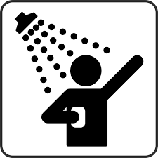
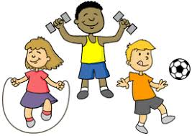
Text #1: Video Games Hurt Kids’ Brains

shower screen headache exercise
Kids love to play video games. 9 out of 10 kids play video games, but too much video gaming is unhealthy for them. Some kids play video games too much. They care about playing video games more than they care about school. Video games are all some kids want to do. But playing video games all the time is bad.
If people are playing video games all the time they might not shower as much. So gaming all the time can make people less clean. Also, it is unhealthy for children to look at a screen all day. It can hurt your eyes. Hurt eyes can cause headaches. Finally, kids need exercise. They should be outside playing sports. Instead, they are sitting inside playing video games.
Playing video games all the time can hurt the body. It can also hurt the brain.
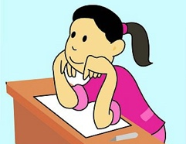
Text #2: Playing Video Games Can Be Good
X
aim shoot glasses focus
Too much video gaming is not a good thing. But what is wrong with one hour of playing? Playing video games can be good.
Video games can help your eyesight. In shooter games, you aim and shoot. It is like exercise for your eyes. Eyesight gets worse when we get older. Video games can help your eyes stay strong so you won’t need glasses. Also, many video games are played with other people. Kids can make lots of new friends playing video games. Finally, video games also help with learning. Video games move fast. You have to focus a lot. This helps you in school. You can focus when a teacher is talking.
Video games can help kids. People just say, "Too many video games is so bad." It is important to look at the good things about playing video games too, not just the bad things.

Name: _______________ Date:____________ Class: ______

- What is the author’s main point in Article 1?

_______________________________________________________________________________________
_______________________________________________________________________________________
_______________________________________________________________________________________
_______________________________________________________________________________________
- What is the author’s main point in Article 2?

_______________________________________________________________________________________
_______________________________________________________________________________________
_______________________________________________________________________________________
_______________________________________________________________________________________

- How are these main points similar? How are they different?

_______________________________________________________________________________________
_______________________________________________________________________________________
_______________________________________________________________________________________
_______________________________________________________________________________________

