Text #1: Video Games Can Be Bad

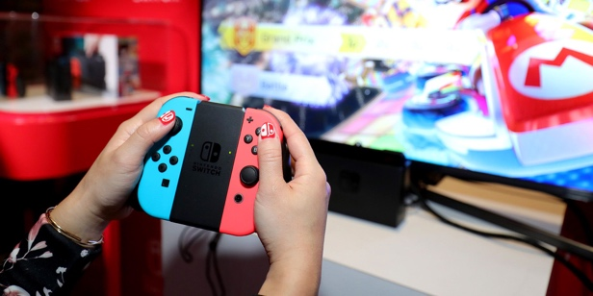
Kids love to play video games.

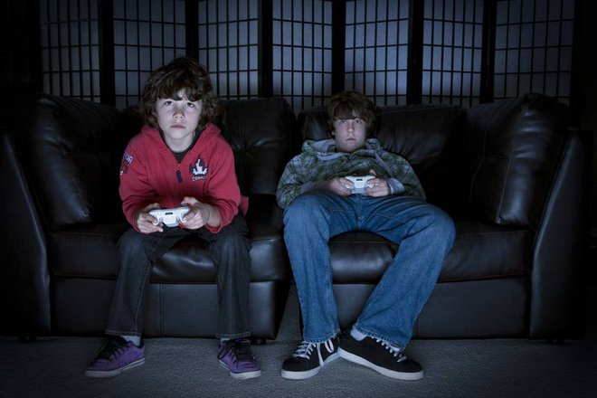
Many, many kids play video games.
But too much video games is not healthy 健康.

Some kids play video games too much.
They care about video games more than school.

But playing video games all the time is bad.
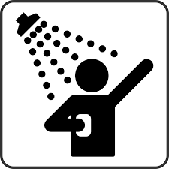
If people are playing video games too much, they might not
shower as much.
So playing video games too much can make people less clean.
Also, it can hurt your eyes to a screen all day.
Hurt eyes can cause headaches.

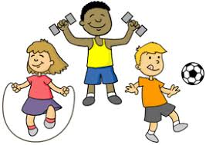
Finally, kids need exercise.
Kids should be outside playing sports.
Instead, they are sitting inside playing video games.

Text #2: Playing Video Games Can Be Good
Playing video games too much is not a good thing.
But, playing a little video games can be good.
Video games can help your eyes.
In shooting games, you aim and shoot.
It is like exercise for your eyes. Aim Shoot

Video games can help your eyes stay strong so you won’t need glasses.

Also, many video games are played with other people.
Kids can make lots of new friends playing video games.

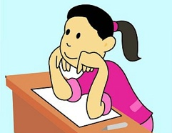
Finally, video games also helps kids learn.
Video games move fast.
You have to focus 集中注意力 a lot.
This helps you in school.
You can focus when a teacher is talking.
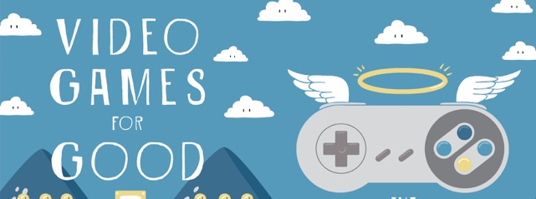
People say, "Too many video games is so bad."
It is important to look at the good things about playing
video games.
Not just the bad things.

Name: _______________ Date:____________ Class: ______

- What is the author’s main point in Article 1?
healthy

outside
shower
exercise
headache
screen
clean
playing sports
inside

Playing too much video games is ______________ because….

- What is the author’s main point in Article 2?
healthy

exercise
learn
glasses
shooting
teacher
aim
shoot
focus 集中注意力

Playing too much video games is ______________ because….

- How are these main points similar? How are they different?

