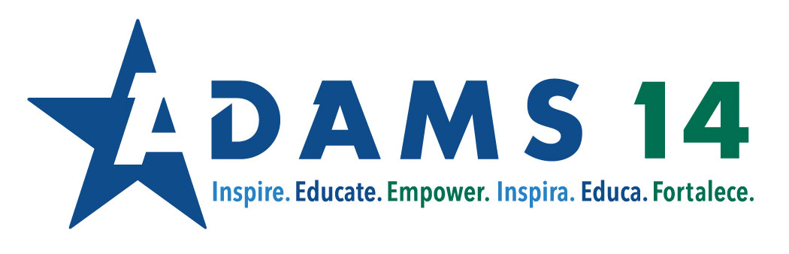
Culturally and Linguistically Diverse Education

Guidance for Elementary Dedicated ELD Block during Remote Learning

Area of Focus During Remote Learning:
Due to the nature of online learning, it is imperative that students have oral language opportunities daily. These opportunities need to be provided by the teacher and/or paraeducator so that students can take their oral production and apply it in writing as well.

Required Components:

Oral language minimum: 10 minutes per day (Note: this oral time is dedicated to eventual writing product expectation for student--note: not all of this oral production has to be in real-time with the teacher. It can be done asynchronously via podcast, recording, casting, etc.)

Example: After teacher modeling, students produce short answers on Flipgrid, then provide oral feedback to each other on FlipGrid. Or students clarify understanding and brainstorm ideas in Google Meet or SeeSaw, then students produce a short personal narrative piece or mini-speech in FlipGrid or SeeSaw.

Oral and Written Practice can be:
- Peer-to-peer
- Individual
- Small group
- Whole group

Writing minimum: 5 minutes per day

Example: response to learning to summarize in a few sentences (student reflection journal, exit ticket, note-catcher, diagram, response to text questions) or write out scripts for longer oral output (elevator speeches, oral narratives)

Suggested Lesson Flow

Direct Instruction
Description: Target language is identified and explicitly taught and modeled. Teachers use class Google Meet time and explicit instruction videos to directly teach and model language.

Projected time: 5-10 minutes

Strategies/Focus  Think Alouds  Language Model  Text-analysis  Modeling | Resources  Curriculum videos  Screencasts  YouTube  White board (digital or actual)  Pear Deck (interactive presentations)

Oral Language Production
Description:
Students have opportunities to orally practice language and produce the target language. This language production can be used as a formative assessment or check for understanding. Students use target vocabulary, target functions, and target forms of language.

Projected time: 10 minutes

Strategies  Students create videos or podcasts  Partner discourse using Talking Cards  Prompts with responses  Give one get one with breakouts  Numbered heads together | Resources  Discussion in Google Meet Groups  Flipgrid  VoiceThread  Voice recordings in Google Docs

Written Language Practice
Description:
Students have opportunities to practice language and produce the target language through writing. This language production can be used as a formative assessment or check for understanding.
Projected time: 5 minutes

Strategies  Students outline and write scripts to create videos or podcasts  Students write notes in a classroom catcher, individual catcher, etc. | Resources  Jamboard  Answer-garden  Google Docs

Providing Feedback/Closure
Description:
Teacher can address patterns observed during language production and provide feedback to groups and closure. Feedback can be given synchronously during whole group closure or asynchronously via Google Classroom.
Projected time: 2-5 minutes
Strategies  Review target language  Whole group re-teaching  Recasting rephrasing  Questioning  White board feedback or suggested language use | Resources  Google Classroom  FlipGrid  SeeSaw  White board

Independent Reading Practice
Description: Students have opportunities to independently read at the appropriate level of text. This can include reading for a specific content area of focus or study, or other areas of reading interest.
Projected time: 15 minutes

Strategies  Literature circles (upper elementary)  Book studies (upper elementary)  Reading Competitions  - Home reading logs with response  DEAR: Drop Everything And Read (specific timeframes throughout the week) | Resources  Myon  Wonders  Maravillas  Books at home  Learning Ally  Newsela

Assessments
Assess students weekly with suggested assessments in scope and sequence with support of the following:
- WIDA Speaking Rubric
- WIDA Writing Rubric

Resources
Primary (K-2)
- Kinder Scope and Sequence with suggested weekly assessments
- Kinder Can Do Name Chart

- 1st Grade Scope and Sequence with suggested weekly assessments
- Grade 1 Can Do Name Chart

- 2nd Grade Scope and Sequence with suggested weekly assessments
- Grades 2-3 Can Do Name Chart

Grades 3-5
Grade 3 Scope and Sequence with assessments
Grades 2-3 Can Do Name Chart
Grade 4 Scope and Sequence with assessments
Grade 5 Scope and Sequence with assessments
Grades 4-5 Can Do Name Chart

ALD Block Resources:
Grade 3 Scope and Sequence with assessments
Grade 4 Scope and Sequence with assessments
Grade 5 Scope and Sequence with assessments

Things to consider:
- Use of paraeducators to support students in oral/written practice time either synchronously or asynchronously.
- Can paras be used to regroup or breakout students with additional needs?
- What will end assessment look like vs. formative assessment?
- What will reteaching look like and can I work with other ELD levels in my building to meet specific students’ needs?

Classroom Look-Fors
ELD Observation Tool for in-person learning | ELD Observation Tool for Online

Remote Learning Support Links
- EdTech Remote Learning Support
- Lesson Plan Checklist for SIOP
- ELD Self-Reflection with Online Considerations
- How to use Google Meet
- How to use FlipGrid
- How to insert audio comments into Google Docs
- How to screenshot and crop (Anticipatory Set how to put in template) MAC | PC
- How to record and publish video
- How to screencast MAC | PC
- How to assign work digitally via Google Classroom

