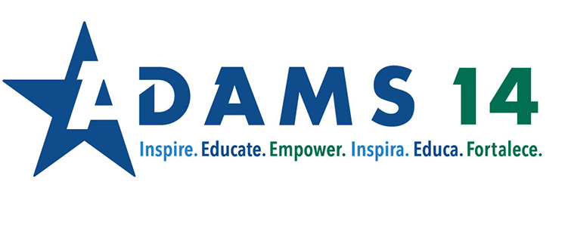
Planning for Multilingual Learners
Backwards Plan
- Identify the content that students should learn and be able to do
- Identify the language that students will need to be able to do what is required at the end of the lesson
  - What is the function of the language?
    - Elaborate and Description
    - Compare Contrast
    - Preposition and Support
    - Sequence
    - Summarize
    - WIDA Key Uses
  - What is the key vocabulary students will need to understand the concept?
- Create an essential question that is relevant and interesting
CM Resources:
- CM Function Tools - Elementary
- CM Function Tools - Secondary

When scripting instructions, keep in mind the linguistic complexity of the instructions: use fewer complex sentences and chunk steps into bite sizes
Choosing Resources
- Evaluate the readability of the resource
  - How much text are we expecting students to access?
  - Are there graphics, charts, or other images students need so that they can access?
  - Are there any terms that may be confusing for language learners?
    - Words with multiple meetings
    - Idioms or play on words
    - https://www.youtube.com/watch?v=D6HUv2eFdLg
Build Background
- Link to student background knowledge
- Consider using high interest pictures with compelling questions for students who do not have access to internet
- Use video and other media to support connections students already have to the content
- Present vocabulary in interesting and understandable ways
  - Identify cognates
  - Present the Spanish term for the work
Comprehensible Input
- Use graphic organizers to support access to resources
- Set specific purpose when reading
  - First read: Gist read
  - Second read: Identify words that contribute to the function Explain and Describe

Consider using screencasting technology to model:
- Think alouds
- Specific reading/writing strategies

Interaction
- Finding opportunities for students to talk and orally practice language

Use Google Meet, Google Docs and Audio in Google Docs to facilitate production of language and opportunities for feedback

Strategies
- Using Graphic Organizers with ELLs
- Visual Thinking Strategies for Improved Comprehension
- Five Things Teachers Can Do to Improve Learning for ELLs in the New Year
- Differentiated Instruction for English Language Learners

https://www.colorincolorado.org/ell-strategies-best-practices
Practice and Application
- Provide time for students to practice with peers
- Find ways to give feedback on content and language production

Resources to Support Planning
- How to Develop a Lesson Plan that Includes ELLs
- Language Objectives: The Key to Effective Content Area Instruction for English Learners
- ASCD Article: Lesson Planning to Support to Ensure Optimal Engagement for ELs

